**LAB # 05**

**SUPERVISED LEARNING (DECISION TREE)**

**OBJECTIVE:**

Implementing supervised learning, DTS algorithm for training, testing and classification.

**LAB TASKS:**

1. Implement the Decision tree algorithm on the data given in the table. 1 and predict the new entry entered by the user.

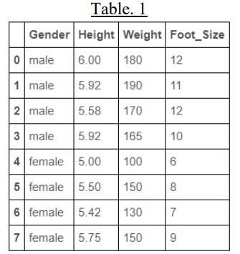

|  |  |
| --- | --- |
| *SOURCE CODE:* |  |
|  | |

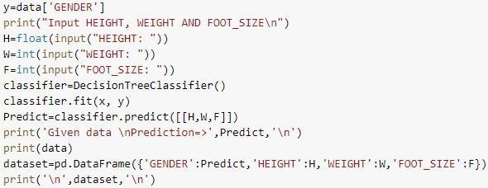

*OUTPUT*

**:**

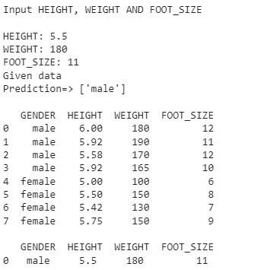

1. Implement Decision Tree using table. 1 in such a way that the new entry becomes the part of the given dataset.

|  |
| --- |
| *SOURCE CODE:* |
|  |

|  |  |  |  |  |
| --- | --- | --- | --- | --- |
|  | |  | | --- | |  | | *O UTPUT:* | |  | |
|  |

1. Implement Decision Tree using table. 1 without the use of Pandas library. You can use numpy.



***SOURCE CODE***



**:**

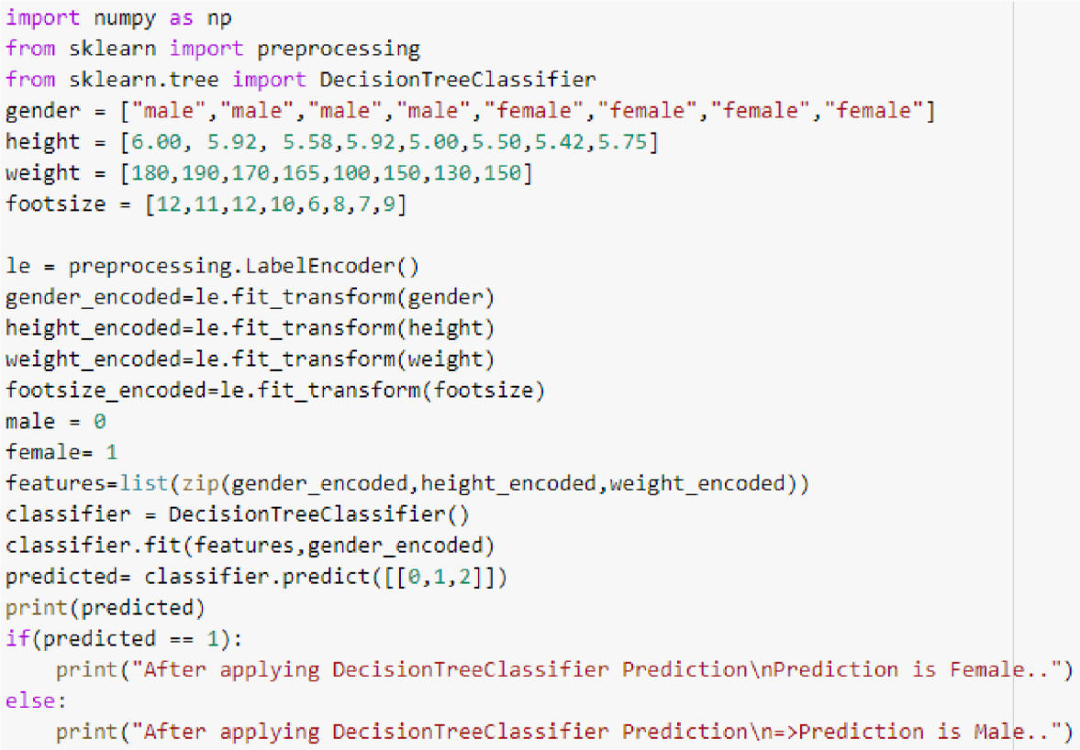

***OUTPUT*:**

